Cheap AIS Plotter – David DeLong – 12/27/13
This document describes how to build an AIS plotter using a $20 tuner/antenna, a USB GPS receiver, and a laptop computer. The way the unit connects together is shown in the diagram below. The instructions to build each component/download each software package then follow.
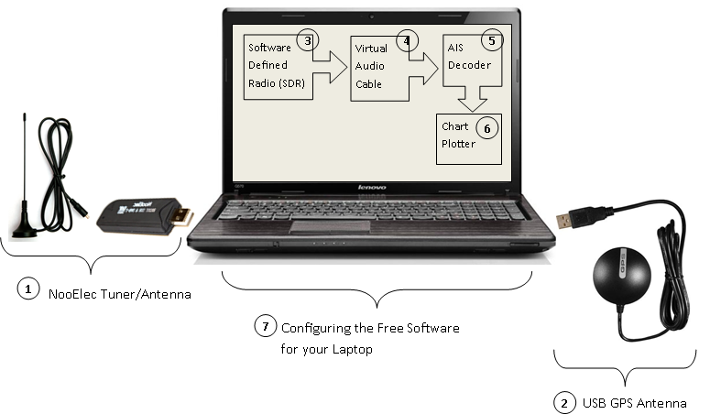
Here is the result you get when the AIS system is fully up and running.
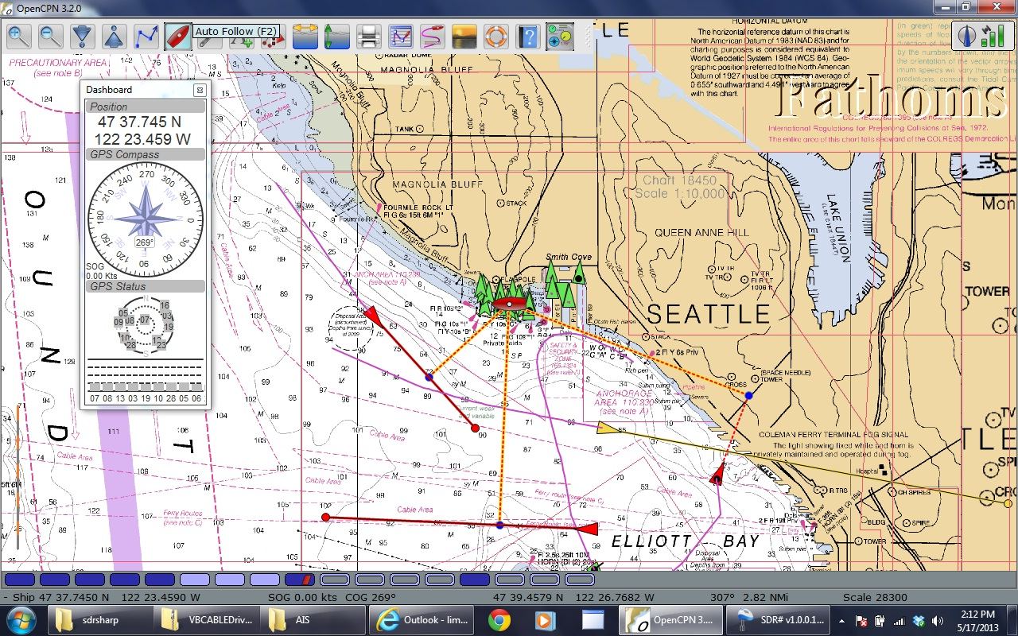
Tuner/Antenna:
1
- Buy the NooElec Tuner/Antenna (I ordered it Friday and received it Monday):
- http://www.amazon.com/NooElec-RTL-SDR-RTL2832U-Software-Packages/dp/B008S7AVTC/ref=sr_1_1?ie=UTF8&qid=1365112054&sr=8-1&keywords=sdr
- TBD – Modify the antenna
USB GPS Antenna
2
- If you do not have GPS on your computer, here is a cheap one that works fine: http://www.amazon.com/GlobalSat-BU-353-USB-GPS-Receiver/dp/B000PKX2KA/ref=sr_1_1?ie=UTF8&qid=1388107039&sr=8-1&keywords=gps+puck
Software Defined Radio (SDR):
3
- Download the software and drivers:
- http://sdrsharp.com/downloads/sdr-install.zip
- Unzip it
- Run install.bat (downloads all of the SW into the same folder)
- Install the driver
- Run ZADIG.EXE (downloaded above)
- Follow instructions here: http://rtlsdr.org/softwarewindows
Virtual Audio Cable (VAC):
4
Each "cable" is like a sound device allowing applications to use it as an input or output device. All applications use a cable as an output device get summed together and routed to all applications using the cable as an input device. You can choose either option below:
- Free one!: http://vb-audio.pagesperso-orange.fr/Cable/index.htm
AIS decoder (AISMON):
5
An application that decodes AIS burst in software and sends the information as NMEA sentences to serial or UDP port. Download and install from here: http://groups.yahoo.com/group/aismon/
Chart Plotting software (OPENcpn):
6
OPENcpn is a free open source chart plotting application. It has powerful data multiplexing capabilities allowing the GPS and AIS NMEA data to be combined and repeated for other devices. A simple application is repeating the data for other computers on the network to use for chart plotting and displaying AIS traffic. Download and install from here: http://opencpn.org/ocpn/
Configuration (putting it all together):
7
- Receiver
  - Audio output: Cable Input (VB-Audio Virtual)
  - Select device: RTL-SDR/USB
  - Select frequency: 161.975
  - Select NFM
  - Start
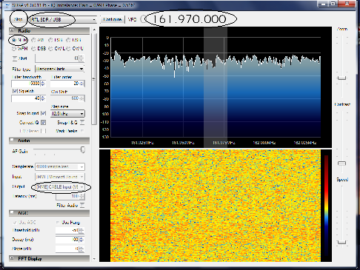

- AISMon
  - Select audio input: Cable Output (VB-Audio Virtual)
  - Select and enable UDP output: 127.0.0.1:10110
  - 48000 sample rate
  - Start Monitoring
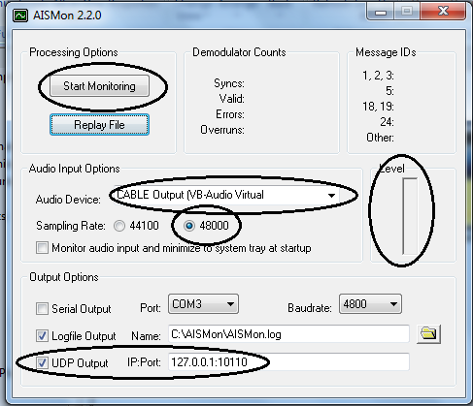

- OpenCPN
  - Options-Connections:
    - Add Connection
    - Network
    - Protocol: UDP
    - Address: 127.0.0.1
